<https://app.powerbi.com/groups/3f32b3ca-ea4a-4344-9d8c-dee3615741e9/reports/6d2afa6c-a38d-4a92-a379-b70dc0e00ddc/ReportSection71b8f07964455cbcd7c4>

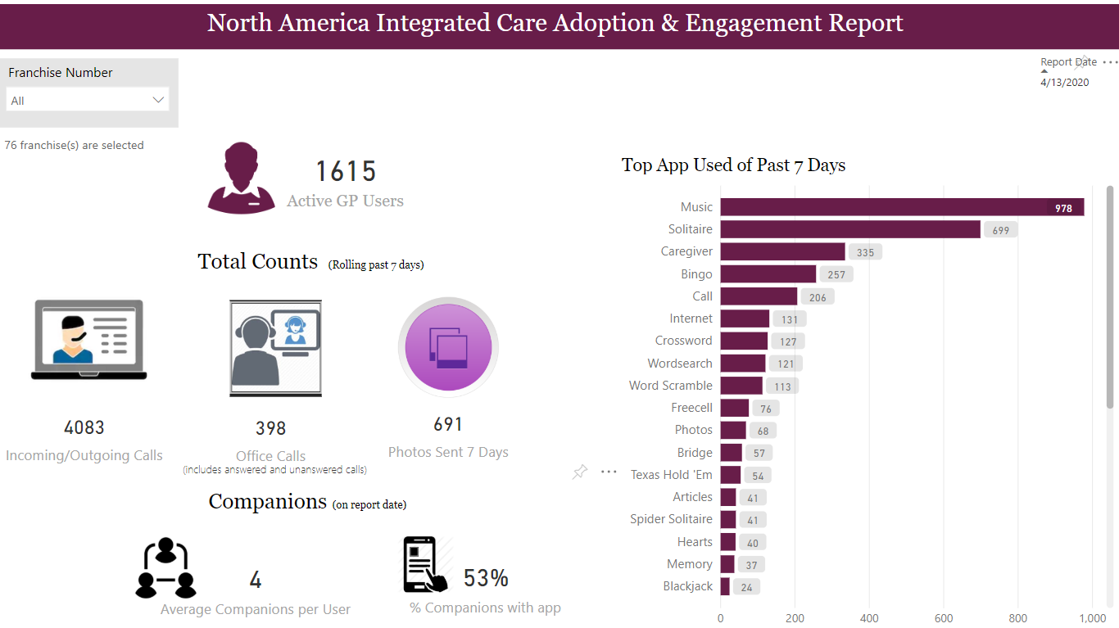

<https://app.powerbi.com/groups/3f32b3ca-ea4a-4344-9d8c-dee3615741e9/reports/6d2afa6c-a38d-4a92-a379-b70dc0e00ddc/ReportSection>

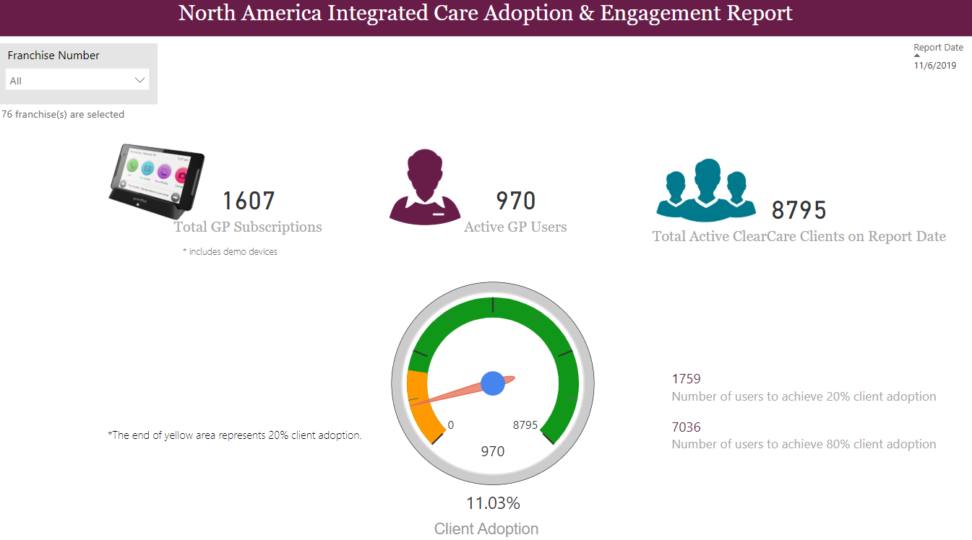

<https://app.powerbi.com/groups/me/reports/ebd8f007-1c97-4d72-91ad-acd11815cad9/ReportSectionf252f66b13b992067396>

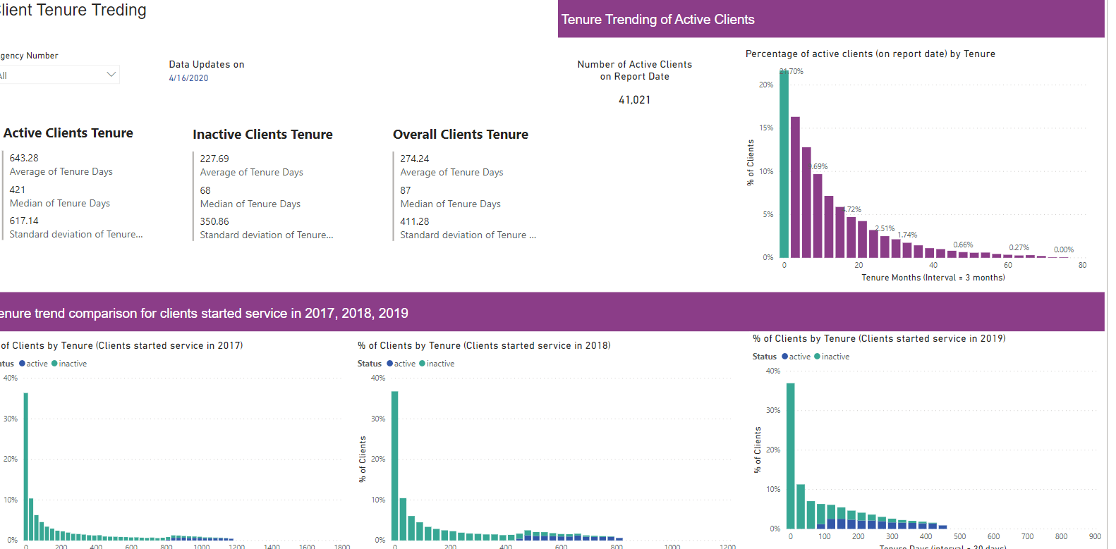

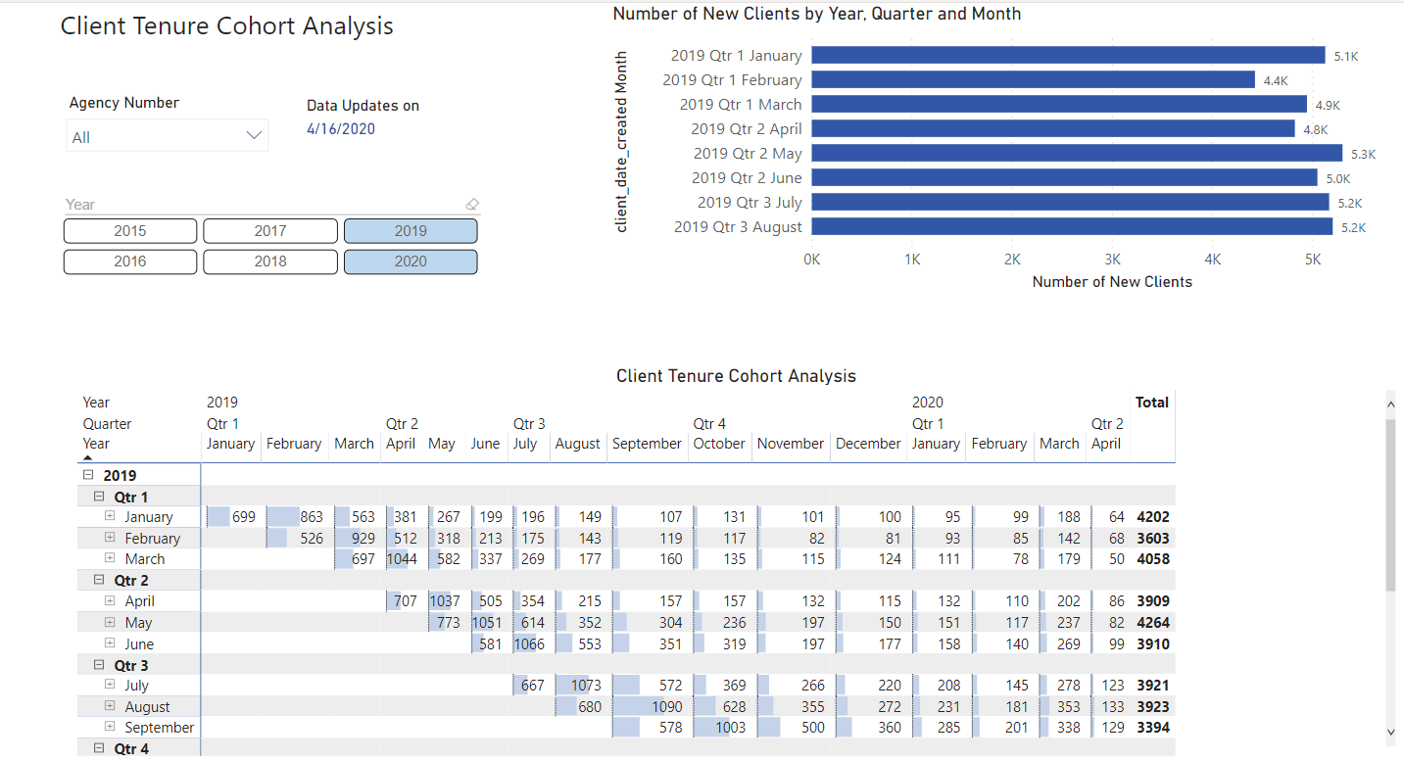

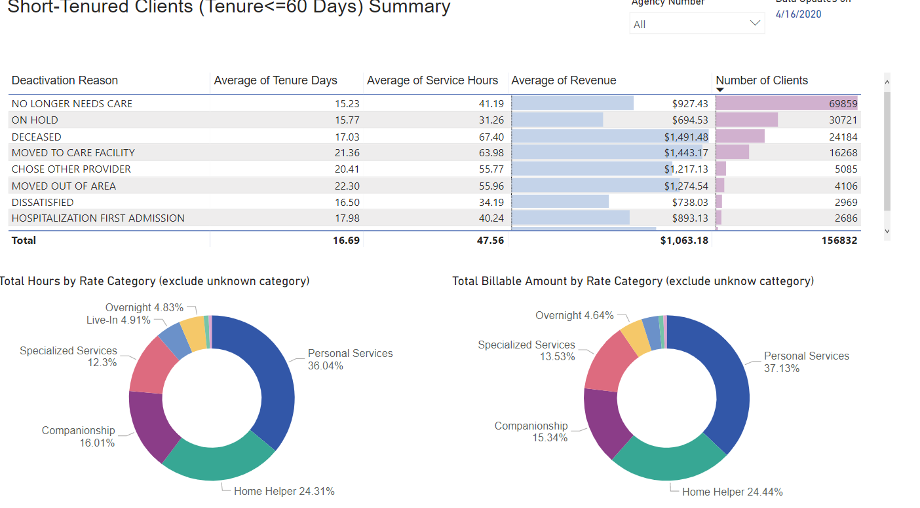

<https://app.powerbi.com/groups/3f32b3ca-ea4a-4344-9d8c-dee3615741e9/reports/de212782-724b-498a-b411-009ee9778719/ReportSectiond0dcec086cdaa95f48e7>

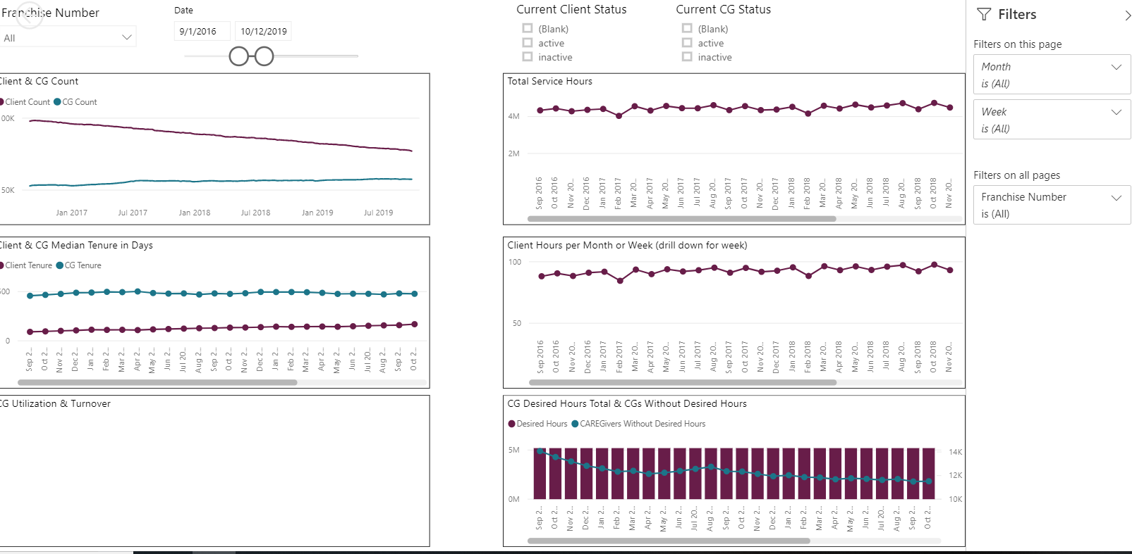

<https://app.powerbi.com/groups/me/reports/4c6dc52c-3c31-4c67-a90a-60a0a480ef7c/ReportSectionc60d340c6de108b16c24>

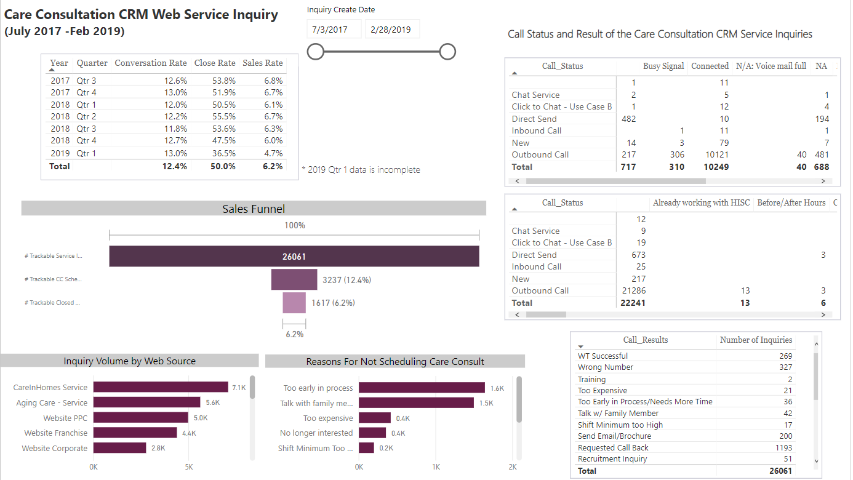

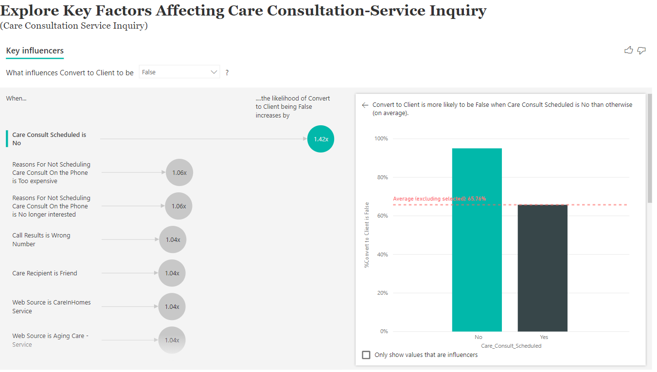

<https://app.powerbi.com/groups/me/reports/e6d34467-dfc6-47c0-8d23-f77cd73ca9d7/ReportSection>

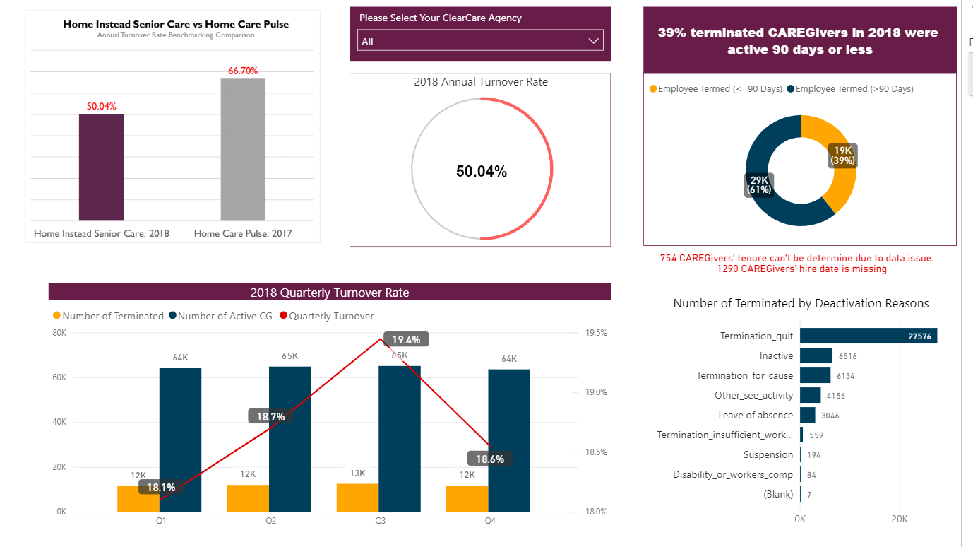

<https://app.powerbi.com/groups/me/apps/99096226-1dbb-4f64-8492-449c0f5b9803/reports/48b70c02-06a4-41f0-bfca-293f86084878/ReportSectioncdac015b9d20d8bca5e0>

